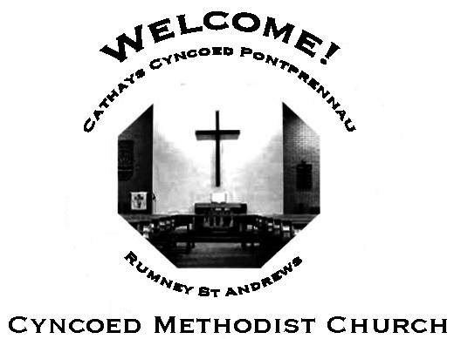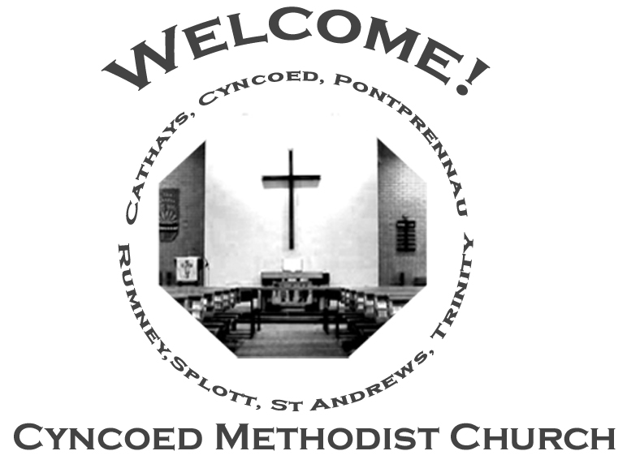+- aster da

***Services***

**Steward: Alison Harrison**

**9.15am Rev. Kofi Amissah - Communion**

**Readings:** *Isaiah 1: 1, 10-20; Psalm 50: 1-8, 22-23; Hebrews 11: 1-3, 8-16;  
 Luke 12: 32-40*

**Church Notices for Sunday 7th August 2022**

**19th Sunday in Ordinary Time**

**No More Covid Restrictions**

As we are all aware, all COVID restrictions have been lifted. There are  
therefore no restrictions applicable to our services or any gathering in  
the Cyncoed Methodist building. We are however aware that Covid is still  
around. For this reason, we encourage that when in the Cyncoed Methodist building, everyone must graciously respect the preferences of other members of the congregation and the community, especially if people choose to maintain any of the preventive protocols.

***At Cyncoed Methodist Church***

We are called to tell God’s story by living as God’s people through:

* Preaching and teaching the gospel
* Encouraging spiritual growth
* Outreach in the community
* Responding to opportunities for change

**All inspired by God centred worship and prayer**.

Bible-Dipping II

Be pleasant, be interesting, use the time well and choose your words carefully. *(Colossians)*

People will drift; they will trust in anything but God; they’ll blame anyone but themselves. But it will not always be like that. *(Isaiah)*

How high are God’s standards? Higher than most people imagine. You know about ‘Do not murder’ but anger can be bad, too. Don’t turn up to church nursing ‘issues’ about other people. Make your peace, settle your disputes, then come. *(Matthew)*

One day, the people who walk in darkness will see a great light, the sun will dawn on those who live in a land as dark as death. The sign will be a child, one who will be called wonderful Guide, mighty God, everlasting Father, Prince of Peace. *(Isaiah)*

It doesn’t matter what you give - flour, bread, yeast, honey - so long as it’s given with love, thought and care. *(Leviticus)*

Second rate work? It looks as if you’re not thankful for what you’ve got or sorry for things you get wrong. *(Leviticus)*

If you let anyone change your mind for you, let it be God. *(Romans)*

***We continue to pray for those members of our Church Family and Friends who are unwell and all those who mourn.***

**Church Family News and Prayers**

**Notices**

* **Coffee Morning:** On Saturday August 6th, from 10am - 12md, the stewards are holding a Coffee Morning in aide of Church Funds. As well as tea and coffee (as well as biscuits!) there will be a cake stall and a Bring and Buy stall - contributions for both are needed please. Admission is £2.50p at the door so please come and share the fellowship.
* **Door Steward Volunteers:** As the rota for door stewards has been so successful it will continue for the next 3 months, please continue to write names against dates on which you are able to help, thank you to everyone who has volunteered so far.

Sue Tester

* **2022/23 Prayer Manual:** There is a sheet on the vestibule table for anyone who would like a 2022/23 prayer manual.

Orders will be taken on Sunday 31st July.

* **Sunday 21st August** is a Local Arrangement service.

If anyone has a favourite hymn or would like to read a poem or reading please let me or any of the stewards know by Sunday 14th so that we can put an order of service together.

Thankyou Sue Tester

* **Outreach Magazine** I am hoping that you will consider submitting a contribution for the 'Autumn Outreach'

whether you have done it before or be it for the first time.

Photos, news, poems, reflections, stories, articles etc. All contributions will be very welcome!!

Submissions can be left in the ‘Outreach tray’ in the church Office. Deadline for submissions is Sunday 21st August

Many thanks, Anne Tucker

**The Ministerial Team:**

**Rev. Kofi Amissah**

*Tel: 029 2030 8392* [*kofi.amissah@methodist.org.uk*](mailto:kofi.amissah@methodist.org.uk)

**Rev. Alexis Mahoney**

*Tel: 029 2030 0321* *revalexismahoney@gmail.com*

**Family & Community Lay Worker - Helen Osborne**

*Tel: 029 2039 3439, mobile 07788 701 129,* *helen.osborne11@btinternet.com*

**Church Office: 029 2039 3439**

*cyncoedmethodistchurch@gmail.com*

**Sunday 14th August 2022**

**20th Sunday in Ordinary Time**

**10.30am Rev. Kofi Amissah – Communion**

**JOINT SERVICE AT LLANISHEN METHODIST CHURCH**

**NO SERVICE AT CYNCOED**

**Readings:** *Isaiah 5: 1-7; Psalm 80: 1-2, 8-19; Hebrews 11: 29 - 12: 2;*

*Luke 12: 49-56*

next

8. Amos 8: 1-12; Psalm 52; Colossians 1: 15-28; Luke 10: 38-42

T

Please send items for the church notices to the Church Office

or email to cyncoedmethodistchurch@gmail.com

before 5.00pm on Wednesday.

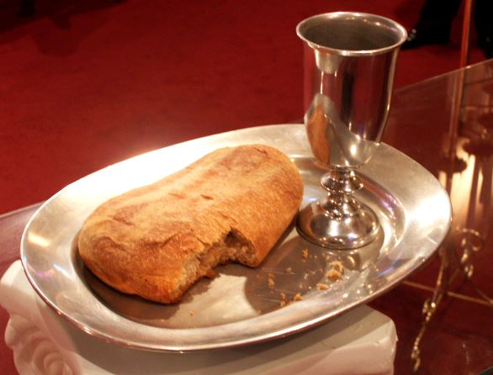

**Informal mid-week Communion**

**The next Thursday morning Communion will be at 10.30am on 1st September 2022**

**Cyncoed Church Premises**

**For Out of Hours or Emergency access to the Cyncoed Church Premises**

**please call Martin on 07849 632 394 or**

**email:**[**cyncoedmethodistchurch@gmail.com**](mailto:cyncoedmethodistchurch@gmail.com)