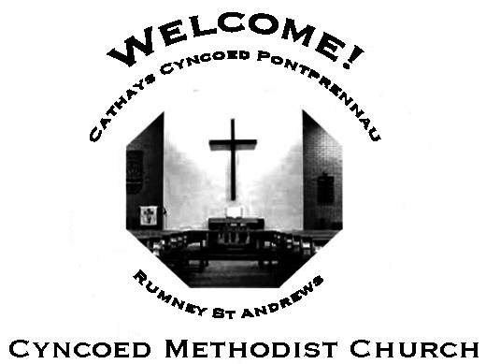
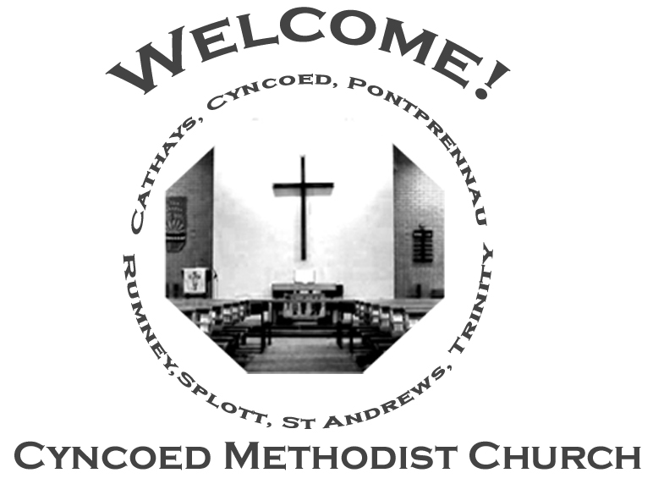
+- aster da
Church Notices for Sunday 31st July 2022
18th Sunday in Ordinary Time
Services
Steward: Jenny Siddall

10.30am Gauri Taylor-Nayar

6.00pm Rev. Cathy Gale – Circuit Zoom Service

Readings: Hosea 11: 1-11; Psalm 107: 1-9, 43; Colossians 3: 1-11;
Luke 12: 13-21

No More Covid Restrictions
As we are all aware, all COVID restrictions have been lifted. There are
therefore no restrictions applicable to our services or any gathering in
the Cyncoed Methodist building. We are however aware that Covid is still
around. For this reason, we encourage that when in the Cyncoed Methodist building, everyone must graciously respect the preferences of other members of the congregation and the community, especially if people choose to maintain any of the preventive protocols.

At Cyncoed Methodist Church

We are called to tell God’s story by living as God’s people through:
- Preaching and teaching the gospel
- Encouraging spiritual growth
- Outreach in the community
- Responding to opportunities for change

All inspired by God centred worship and prayer.
Oh…

Look, I’ll be straight with you; I don’t believe any of this stuff you’ve been saying but I’m a fair man. Now, see that water over there. You turn it into wine for me and I’ll think again.

Oh … well, straight up, I’m impressed. I don’t mind saying so. Of course, I expect it was rigged beforehand and one of your assistants switched things. But you did it well. You know what you really need to do to convince me is to do something that
can’t be rigged. Now I know someone at the hospital who could sure use someone like you…if you are real. What? Go now? Anything to oblige. Yes, this is her. That’s
right – for years. Hey, how did you know that? What did you say to her? Just a minute, my lady, you can’t get up, your legs will never…

Oh. You sure aren’t any run-of-the-mill magician, are you? I’ve got a contact in television who’d really be interested in you. I reckon I could set you up for life.
Believe in you? Aw, come on. A couple of tricks. OK, don’t get angry. They were good. I grant you that. All right, go home. Don’t say I didn’t try to help you. Hey, you can’t go that way: it’s the lake. Hey, come back, you’ll drown!

Oh … well, I’m a fair man. I can’t deny I’ve seen it. And, at the end of the day, one ought to make the most reasonable decision which takes account of the facts. My
eyesight must need testing.

We continue to pray for those members of our Church Family and Friends who are unwell and all those who mourn.

Church Family News and Prayers

Notices
- Circuit Zoom Service:

- Door Steward Volunteers: As the rota for door stewards has been so successful it will continue for the next 3 months, please continue to write names against dates that you able to help, thank you to everyone who has volunteered so far.
Sue Tester
- 2022/23 Prayer Manual: There is a sheet on the vestibule table for anyone who would like a 2022/23 prayer manual.
Orders will be taken on Sunday 31st July.
- Coffee Morning: On Saturday August 6th, from 10am - 12md, the stewards are holding a Coffee Morning in aide of Church Funds. As well as tea and coffee (as well as biscuits!) there will be a cake stall and a Bring and Buy stall - contributions for both are needed please. Admission is £2.50p at the door so please come and share the fellowship.
- Sunday 21st August is a Local Arrangement service.
If anyone has a favourite hymn or would like to read a poem or reading please let me or any of the stewards know by Sunday 14th so that we can put an order of service together.
Thankyou Sue Tester
- Outreach Magazine I am hoping that you will consider submitting a contribution for the 'Autumn Outreach'
whether you have done it before or be it for the first time.
Photos, news, poems, reflections, stories, articles etc. All contributions will be very welcome!!
Submissions can be left in the ‘Outreach tray’ in the church Office. Deadline for submissions is Sunday 21st August
Many thanks, Anne Tucker

The Ministerial Team:
Rev. Kofi Amissah
Tel: 029 2030 8392 kofi.amissah@methodist.org.uk
Rev. Alexis Mahoney
Tel: 029 2030 0321 revalexismahoney@gmail.com
Family & Community Lay Worker - Helen Osborne
Tel: 029 2039 3439, mobile 07788 701 129, helen.osborne11@btinternet.com

Church Office: 029 2039 3439
cyncoedmethodistchurch@gmail.com

Sunday 7th August 2022
Nineteenth Sunday in Ordinary Time

Steward: Alison Harrison

9.15am Rev. Kofi Amissah - Communion

Readings: Isaiah 1: 1, 10-20; Psalm 50: 1-8, 22-23; Hebrews 11: 1-3, 8-16;
Luke 12: 32-40

next

8. Amos 8: 1-12; Psalm 52; Colossians 1: 15-28; Luke 10: 38-42
T
Please send items for the church notices to the Church Office
or email to cyncoedmethodistchurch@gmail.com
before 5.00pm on Wednesday.

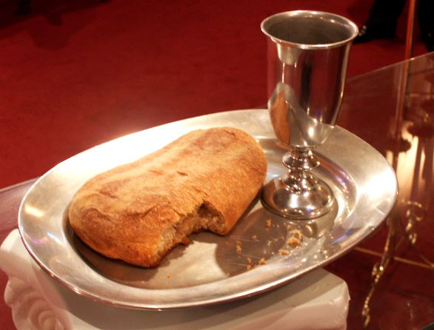
Informal mid-week Communion
The next Thursday morning Communion will be at 10.30am on 1st September 2022

Cyncoed Church Premises

For Out of Hours or Emergency access to the Cyncoed Church Premises
please call Martin on 07849 632 394 or
email: cyncoedmethodistchurch@gmail.com

