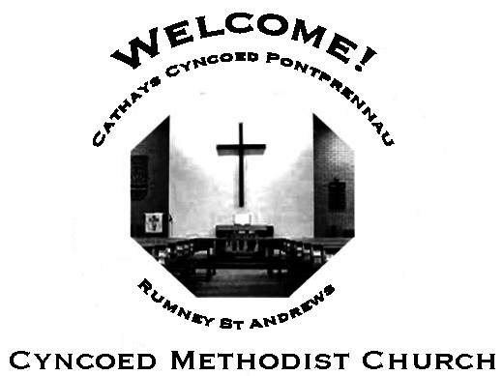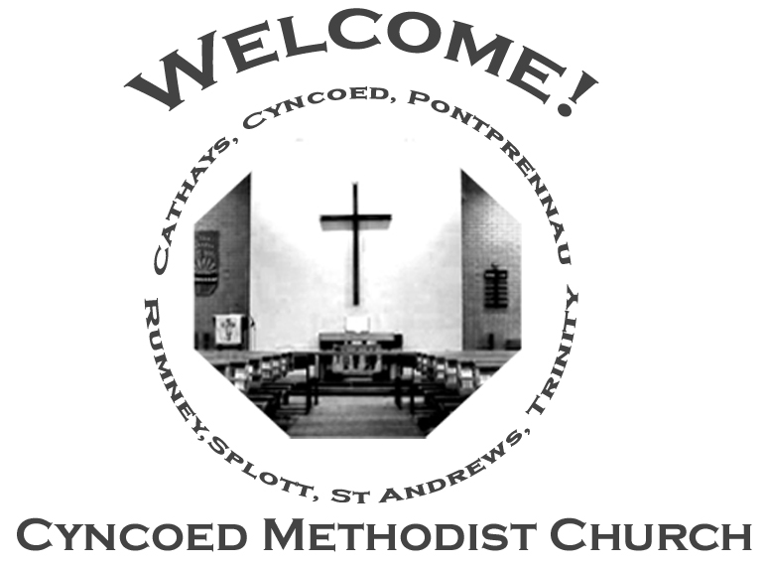+- aster da

***Services***

**Steward: Jenny Siddall**

**10.30am Dave Kitchen**

**6.00pm Circuit Zoom Service**

**Readings*:*** *2 Kings 2: 1-2, 6-14; Psalm 77: 1-2, 11-20; Galatians 5: 1, 13-25;*

*Luke 9: 51-62*

**No More Covid Restrictions**

As we are all aware, all COVID restrictions have been lifted. There are  
therefore no restrictions applicable to our services or any gathering in  
the Cyncoed Methodist building. We are however aware that Covid is still  
around. For this reason, we encourage that when in the Cyncoed Methodist building, everyone must graciously respect the preferences of other members of the congregation and the community, especially if people choose to maintain any of the preventive protocols.

***At Cyncoed Methodist Church***

We are called to tell God’s story by living as God’s people through:

* Preaching and teaching the gospel
* Encouraging spiritual growth
* Outreach in the community
* Responding to opportunities for change

**All inspired by God centred worship and prayer**.

**Church Notices for Sunday 26th June 2022**

**13th Sunday in Ordinary Time**

# 

# Blissfully imperfect

Welcome to the church of the blissfully imperfect.

Not that being imperfect is bliss.

Far from it.

Makes life a good deal trickier than it should be.

But it’s better than being the cathedral of skin-deep spirituality

Or the chapel of the papered-over cracks.

A church of the imperfect

Is, at least, a place in which you know where you are;

The bliss is in knowing you’re forgiven for where you are.

You can step forward, find faith,

And perhaps help another traveller along the road.

Blissfully imperfect sounds strange

But there is no greater joy

Than to know you are loved in spite of yourself.

It’s like a glimpse of utter light in a midnight sky

As God smiles down upon even you.

So, welcome…this is the place you’ve been looking for.

***We continue to pray for those members of our Church Family and Friends who are unwell and all those who mourn.***

**Church Family News and Prayers**

**Notices**

* **June Circuit Zoom Service -** Sunday 26th June, 6pm  
  Led by Rev. Paul Martin and Mrs Wendy Barwise
* **Door Steward Volunteers:** There will be a sheet on the front table of the Church, would people who are happy to help as Door Stewards please sign on a date that they are available, ideally at least one person per week would be great.

Thank you. Sue Tester

* **Race for Life**:I am hoping to take part in the Cardiff 5K Race for Life on Sunday 10th July to raise funds for Cancer research, if you would like to support me there is a sponsorship form on the table in the foyer, thank you.  Alison Harrison
* **Men’s Breakfast:** The next Men's Breakfast will be on Saturday 9th July at 8.30 in the Fellowship Room.

Come and join us for lovely food, great fellowship and good conversation.

Please book your place by signing the sheet in the church foyer or by emailing  [cyncoedmethodistchurch@gmail.com](mailto:cyncoedmethodistchurch@gmail.com) or messaging to 07788 701129

* **Circuit vacancies for voluntary roles:** The Circuit Meeting is looking to appoint to the following two (voluntary) posts.

1. EDI (Equality, Diversion and Inclusion) Officer
2. Circuit Safeguarding Officer

Information on each of these roles is available on the Methodist Church website. Expressions of interest should come to the Circuit Office by Friday July 22nd, 2022.

**The Inclusive Methodist Church page**

<https://www.methodist.org.uk/about-us/the-methodist-church/the-inclusive-methodist-church/>

**The Methodist Church Safeguarding Page**

<https://www.methodist.org.uk/safeguarding/>

(Sample role descriptions can be found under the safer recruitment section)

**The Ministerial Team:**

**Rev. Kofi Amissah**

*Tel: 029 2030 8392* [*kofi.amissah@methodist.org.uk*](mailto:kofi.amissah@methodist.org.uk)

**Rev. Alexis Mahoney**

*Tel: 029 2030 0321* *revalexismahoney@gmail.com*

**Family & Community Lay Worker - Helen Osborne**

*Tel: 029 2039 3439, mobile 07788 701 129,* *helen.osborne11@btinternet.com*

**Church Office: 029 2039 3439**

*cyncoedmethodistchurch@gmail.com*

**Sunday 3rd July 2022**

**Fourteenth Sunday in Ordinary Time**

**Steward: Alison Harrison**

**9.15am Rev. Kofi Amissah - Communion**

**Readings:** *2 Kings 5: 1-14; Psalm 30; Galatians 6: (1-6) 7-16;*

*Luke 10: 1-11, 16-20*

8.

T

Please send items for the church notices to the Church Office

or email to cyncoedmethodistchurch@gmail.com

before 5.00pm on Wednesday.

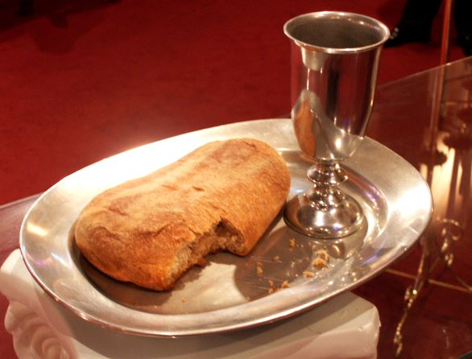

**Informal mid-week Communion**

**There will no Communion on Thursday 30th June.**

**Cyncoed Church Premises**

**For Out of Hours or Emergency access to the Cyncoed Church Premises**

**please call Martin on 07849 632 394 or**

**email:**[**cyncoedmethodistchurch@gmail.com**](mailto:cyncoedmethodistchurch@gmail.com)