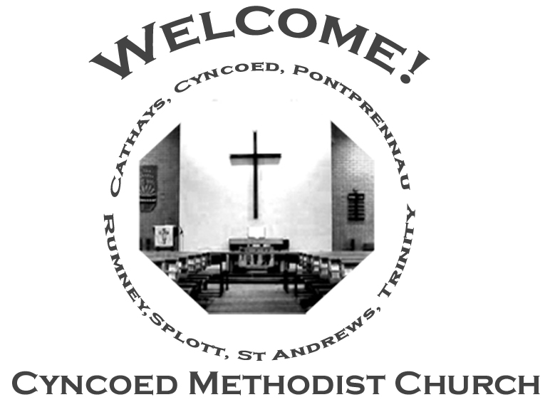+- aster da

***Services***

**Steward: Jenny Siddall**

**10.30am Vera Ruddock**

**6.00pm Rev Alexis Mahoney - Circuit Zoom Service**

**Readings:** *Acts 16: 16-34; Psalm 97; Revelation 22: 12-14, 16-17, 20-21;*

*John 17: 20-26*

**Church Notices for Sunday 29th May 2022**

**Seventh Sunday of Easter**

***At Cyncoed Methodist Church***

We are called to tell God’s story by living as God’s people through:

* Preaching and teaching the gospel
* Encouraging spiritual growth
* Outreach in the community
* Responding to opportunities for change

**All inspired by God centred worship and prayer**.

**Ongoing Covid Precautions:**

**The World Health Organisation clearly recognises that we are still in the middle of the Covid-19 pandemic, with some localities facing increasingly rapid rates of infection. In order to protect all members of the congregation we ask that congregants and visitors: Continue to wear face coverings when inside the church buildings (unless medically exempt). Avoid sitting too close to people who they do not reside with**

Continue to wear face coverings when inside the church buildings (unless medically exempt)

Avoid sitting too close to people who they do not reside with

**Every season**

To every love, there is a season.

A time to start new pages in each other’s stories,

To hold hands, watch the sunset.

A time you should confront the things that hurt,

Then kiss, make up and start again.

A time to march for justice, feed the hungry;

A time to brew a pot of tea.

There is a time to bear a family’s disapproval,

To walk your own road with the one you love.

A time to break the silence with kind words,

Or split the sky with thundercracks of laughter;

A time to see the welcome in another’s eyes

And one to say goodbye with grace.

There’s a time to stay when others leave,

And one for letting go when it’s easier to cling on,

A time to bless the home that makes you safe,

Another to open doors for lost and lonely souls.

A time to smile at all that’s yet to be;

A time to hold hands one last time.

The seasons turn and bring their change

But love’s in every purpose under heaven.

***We continue to pray for those members of our Church Family and Friends who are unwell and all those who mourn.***

**Church Family News and Prayers**

**Notices**

* **Door Steward Volunteers:** There will be a sheet on the front table of the Church, would people who are happy to help as Door Stewards please sign on a date that they are available, ideally at least one person per week would be great.

Thank you. Sue Tester

* **The Annual General Meeting of Cyncoed Methodist Church** will be held at the Church on Tuesday 7th June at 7.30pm.

All Members welcome.

* **Lunch Club** **- a request**. In order to resume our Lunch Club, after our recent enforced break, we are holding a 'Coffee Morning' on Wednesday 1st June from 11.00am.  If anyone feels they would be able to make some cake for this event, that would be much appreciated, so please can you speak to me. In addition, if anyone would like to attend they will be very welcome, and again please let me know.

Many thanks, Helen

* **Men's Breakfast:** We're planning to resume on Saturday 11th June at 8.30am  As before, please sign up if you hope to attend, either by leaving a message at the Office or on the 'Sign-up Sheet' in the Church Foyer. Thanks Helen.

**The Ministerial Team:**

**Rev. Kofi Amissah**

*Tel: 029 2030 8392* [*kofi.amissah@methodist.org.uk*](mailto:kofi.amissah@methodist.org.uk)

**Rev. Alexis Mahoney**

*Tel: 029 2030 0321* *revalexismahoney@gmail.com*

**Family & Community Lay Worker - Helen Osborne**

*Tel: 029 2039 3439, mobile 07788 701 129,* *helen.osborne11@btinternet.com*

**Church Office: 029 2039 3439**

*cyncoedmethodistchurch@gmail.com*

**Sunday 5th June 2022**

**Pentecost**

**Steward: Alison Harrison**

**9.15am Rev Kofi Amissah – Communion**

**Readings*:*** *Acts 2: 1-21 or Genesis 11: 1-9; Psalm 104: 24-34. 35b;*

*Romans 8: 14-17 or Acts 2: 1-21; John 14: 8-17 (25-27)*

8

T

Please send items for the church notices to the Church Office

or email to cyncoedmethodistchurch@gmail.com

before 5.00pm on Wednesday.

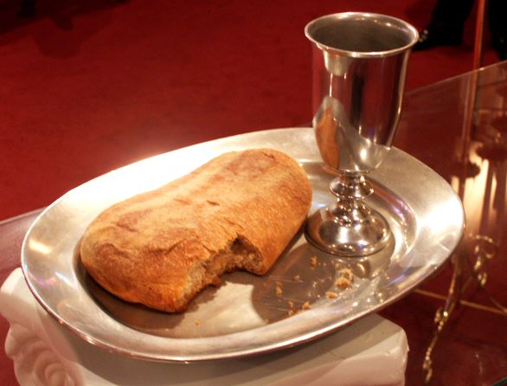

**Informal mid-week Communion**

**Due to next week’s Bank Holiday there will be**

**NO Communion on Thursday 2nd June.**

**Cyncoed Church Premises**

**For Out of Hours or Emergency access to the Cyncoed Church Premises**

**please call Martin on 07849 632 394 or**

**email:**[**cyncoedmethodistchurch@gmail.com**](mailto:cyncoedmethodistchurch@gmail.com)