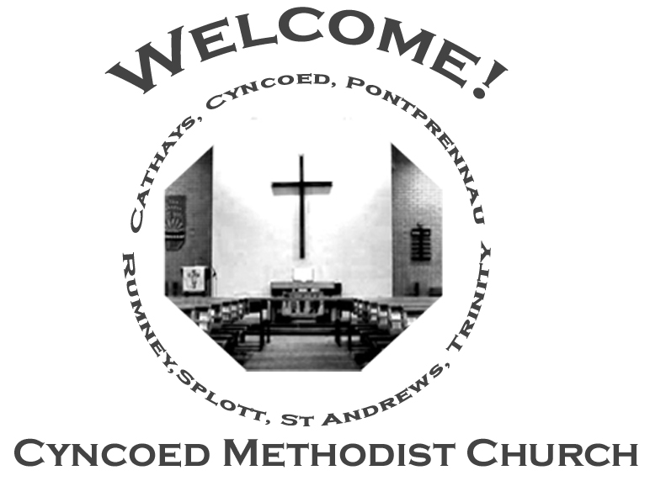+- aster da

***Services***

**Steward: Sue Tester**

**10.30am Local Arrangement**

**Readings:** *Acts 16: 9-15; Psalm 67; Revelation 21:10, 22—22:5;*

*John 14: 23-29 or John 5: 1-9*

**Church Notices for Sunday 22nd May 2022**

**Sixth Sunday of Easter**

***At Cyncoed Methodist Church***

We are called to tell God’s story by living as God’s people through:

* Preaching and teaching the gospel
* Encouraging spiritual growth
* Outreach in the community
* Responding to opportunities for change

**All inspired by God centred worship and prayer**.

**Ongoing Covid Precautions:**

**The World Health Organisation clearly recognises that we are still in the middle of the Covid-19 pandemic, with some localities facing increasingly rapid rates of infection. In order to protect all members of the congregation we ask that congregants and visitors: Continue to wear face coverings when inside the church buildings (unless medically exempt). Avoid sitting too close to people who they do not reside with**

Continue to wear face coverings when inside the church buildings (unless medically exempt)

Avoid sitting too close to people who they do not reside with

**The tutor**

When you tutor, you meet students who think they have a problem. In my case, I got youngsters who were better at maths and science than English which they thought was really difficult. So my first job, usually, was to inspire enough confidence for them have a go.

We live in a world where the news concentrates on what we’re bad at rather than what we’re good at. And, as we suspect anything that has a whiff of overconfidence, we also tend to put ourselves down. Realism is fine. But, if God created this world, he surely didn’t do it so we could shrug our shoulders and say that this or that is totally impossible for us.

The best thing in the whole world for me is when a young person’s face lights up with the recognition that they actually are able to do a task they thought was beyond them. I had a friend with a sign that said: *Miracles we do immediately, the impossible may take a little longer.* That appeals to me. Not because I do miracles but because when you replace a *can’t do* with a *can do*, it feels as if a miracle has happened.

My faith in God begins with a sense that what he wants for me is more than I could hope for or imagine. That’s great but it’s incomplete unless I use it as a springboard for everyday life. If I use fully the gifts God has given me, it will not only make a difference to me, it will also have an impact on those I work with. I can’t do everything but I can do a massive amount more than I sometimes think.

***We continue to pray for those members of our Church Family and Friends who are unwell and all those who mourn.***

**Church Family News and Prayers**

**Notices**

* **Annual General Meeting of Cyncoed Methodist Church** will be held at the Church on Tuesday 7th June at 7.30pm.

All Members welcome. Agenda and Minutes of last meeting to be circulated.

* **Christian Aid Week:** 15th – 21st May 2022. There have been no doorstep collections this year but if you wish and are able to make a donation, there are envelopes available in the church porch. Please remember to Gift Aid your donation if possible.
* **Summer Outreach**: If you would like to contribute an article for our next edition of OUTREACH please will you either email it to me Anne Tucker or if written leave in the Office for my attention. Deadline for submission is Sunday 22nd May
* **Request for Accommodation**: Rev. Klaus Gutwein was a URC Minister in Ely several years ago and worked closely with Ely Methodist Church. He has sent a request through Ely for assistance in housing a student from his Church in Germany from the end of July through August. Colin is 17 and will be starting a bilingual school in September and would like the chance to improve his English (which is already quite good). If anyone is interested, please contact the Circuit Office [office@cardiffmethodist.org.uk](mailto:office@cardiffmethodist.org.uk) .
* **Lunch Club** **- a request**. In order to resume our Lunch Club, after our recent enforced break, we are holding a 'Coffee Morning' on Wednesday 1st June from 11.00am.  If anyone feels they would be able to make some cake for this event, that would be much appreciated, so please can you speak to me. In addition, if anyone would like to attend they will be very welcome, and again please let me know.

Many thanks, Helen

**The Ministerial Team:**

**Rev. Kofi Amissah**

*Tel: 029 2030 8392* [*kofi.amissah@methodist.org.uk*](mailto:kofi.amissah@methodist.org.uk)

**Rev. Alexis Mahoney**

*Tel: 029 2030 0321* *revalexismahoney@gmail.com*

**Family & Community Lay Worker - Helen Osborne**

*Tel: 029 2039 3439, mobile 07788 701 129,* *helen.osborne11@btinternet.com*

**Church Office: 029 2039 3439**

*cyncoedmethodistchurch@gmail.com*

**Sunday 29th May 2022**

**Seventh Sunday of Easter**

**Steward: Jenny Siddall**

**10.30am Vera Ruddock**

**6.00pm Rev Alexis Mahoney - Circuit Zoom Service**

**Readings:** *Acts 16: 16-34; Psalm 97; Revelation 22: 12-14, 16-17, 20-21;*

*John 17: 20-26*

8

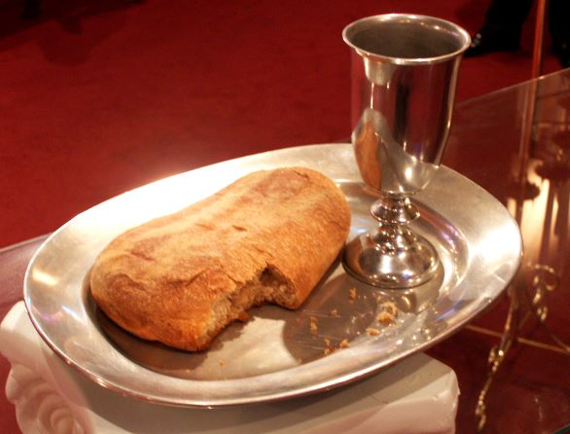

**Informal mid-week Communion**

Thursdays at 10.30am in the Fellowship Room

*An Oasis of peace in a busy week*

**Cyncoed Church Premises**

**For Out of Hours or Emergency access to the Cyncoed Church Premises**

**please call Martin on 07849 632 394 or**

**email:**[**cyncoedmethodistchurch@gmail.com**](mailto:cyncoedmethodistchurch@gmail.com)

T

Please send items for the church notices to the Church Office

or email to cyncoedmethodistchurch@gmail.com

before 5.00pm on Wednesday.