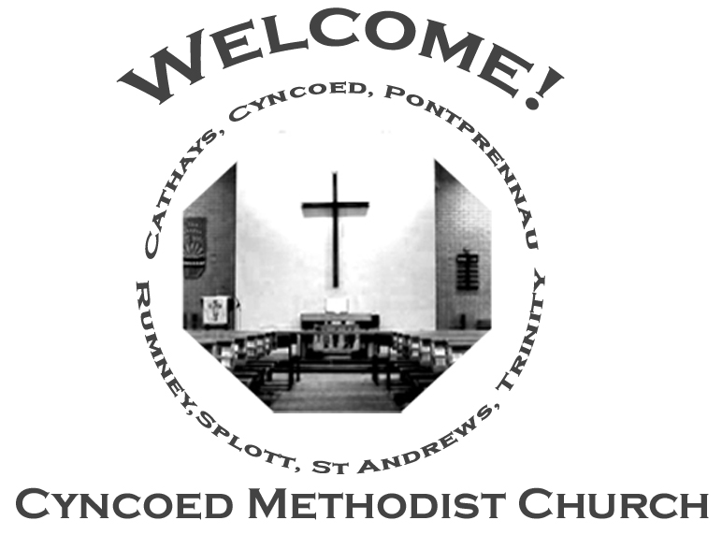+- aster da

***Services***

**Steward: Jenny Siddall**

**10.30am Rev. Kofi Amissah - Communion**

**Readings:** *Acts 9: 36-43; Psalm 23; Revelation 7: 9-17; John 10: 22-30*

**Church Notices for Sunday 8th May 2022**

**Fourth Sunday of Easter**

***At Cyncoed Methodist Church***

We are called to tell God’s story by living as God’s people through:

* Preaching and teaching the gospel
* Encouraging spiritual growth
* Outreach in the community
* Responding to opportunities for change

**All inspired by God centred worship and prayer**.

**Ongoing Covid Precautions:**

**The World Health Organisation clearly recognises that we are still in the middle of the Covid-19 pandemic, with some localities facing increasingly rapid rates of infection. In order to protect all members of the congregation we ask that congregants and visitors: Continue to wear face coverings when inside the church buildings (unless medically exempt). Avoid sitting too close to people who they do not reside with**

Continue to wear face coverings when inside the church buildings (unless medically exempt)

Avoid sitting too close to people who they do not reside with

Prayer for the day

Lord of power and love,

The creator of each new morning,

Who has brought us safely

To the beginning of this day;

Inspire us with your boundless power

So that we neither fail you in what we do

Or let you down by what we avoid doing.

May every minute of our day,

Every word of our mouths

And every action of our hands

Express what is in your mind and heart

So that what we think and what we do

May be lovely in your sight.

Amen

*(from Uncommon Prayers by Dave Kitchen)*

***We continue to pray for those members of our Church Family and Friends who are unwell and all those who mourn.***

**Church Family News and Prayers**

**Notices**

* **Desert Island Hymns:** a Songs of Praise Service, supporting Christian Aid will be at Christchurch, Llanedeyrn Drive on Sunday 15th May at 4pm.
* **Summer Outreach**: If you would like to contribute an article for our next edition of OUTREACH please will you either email it r leave in the Office for my attention.Deadline for submission is Sunday 22nd May  
  Look forward to hearing from you!!  
  Anne Tucker

**The Ministerial Team:**

**Rev. Kofi Amissah**

*Tel: 029 2030 8392* [*kofi.amissah@methodist.org.uk*](mailto:kofi.amissah@methodist.org.uk)

**Rev. Alexis Mahoney**

*Tel: 029 2030 0321* *revalexismahoney@gmail.com*

**Family & Community Lay Worker - Helen Osborne**

*Tel: 029 2039 3439, mobile 07788 701 129,* *helen.osborne11@btinternet.com*

**Church Office: 029 2039 3439**

*cyncoedmethodistchurch@gmail.com*

**Sunday 15th May 2022**

**Fifth Sunday of Easter**

**Steward: Angela and Heather Bailey**

**10.30am Wendy Barwise**

**Readings:** *Acts 11: 1-18; Psalm 148; Revelation 21: 1-6; John 13: 31-35*

8

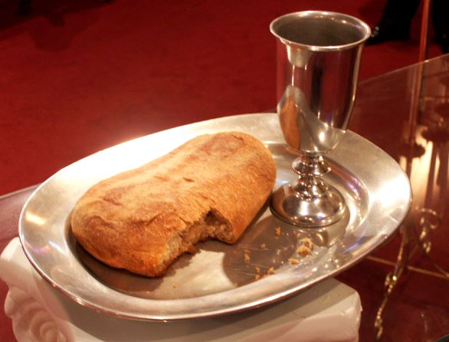

**Informal mid-week Communion**

Thursdays at 10.30am in the Fellowship Room

*An Oasis of peace in a busy week*

**Cyncoed Church Premises**

**For Out of Hours or Emergency access to the Cyncoed Church Premises**

**please call Martin on 07849 632 394 or**

**email:**[**cyncoedmethodistchurch@gmail.com**](mailto:cyncoedmethodistchurch@gmail.com)

T

Please send items for the church notices to the Church Office

or email to cyncoedmethodistchurch@gmail.com

before 5.00pm on Wednesday.