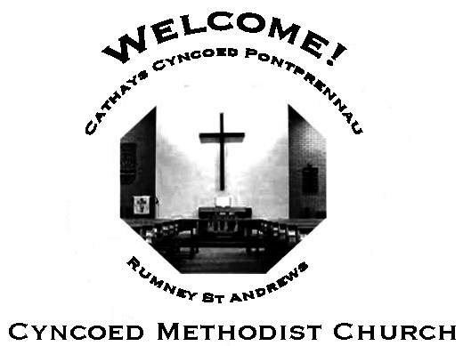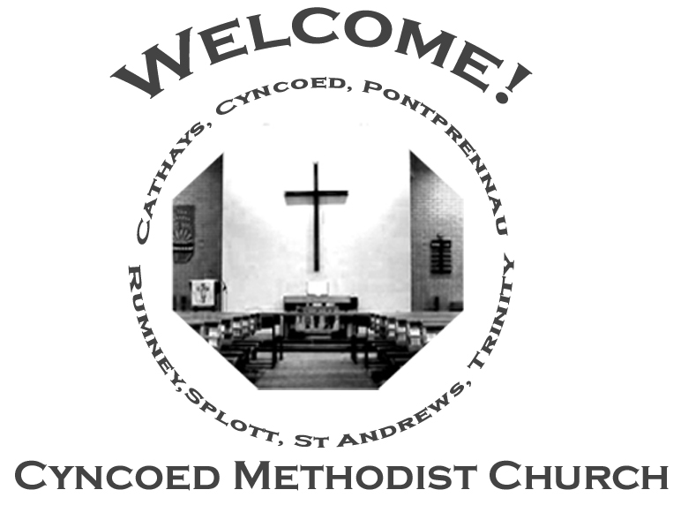+- aster da

***Services***

**Steward: Angela and Heather Bailey**

**10.30am Wendy Barwise**

**Readings:** *Acts 11: 1-18; Psalm 148; Revelation 21: 1-6; John 13: 31-35*

**Church Notices for Sunday 15th May 2022**

**Fifth Sunday of Easter**

***At Cyncoed Methodist Church***

We are called to tell God’s story by living as God’s people through:

* Preaching and teaching the gospel
* Encouraging spiritual growth
* Outreach in the community
* Responding to opportunities for change

**All inspired by God centred worship and prayer**.

**Ongoing Covid Precautions:**

**The World Health Organisation clearly recognises that we are still in the middle of the Covid-19 pandemic, with some localities facing increasingly rapid rates of infection. In order to protect all members of the congregation we ask that congregants and visitors: Continue to wear face coverings when inside the church buildings (unless medically exempt). Avoid sitting too close to people who they do not reside with**

Continue to wear face coverings when inside the church buildings (unless medically exempt)

Avoid sitting too close to people who they do not reside with

Together

In each other’s lives

We always play a part.

Our silence carries words;

The words speak for our heart.

On each other’s shores

Are footprints in the sand.

They mark where paths have crossed;

They speak of how we stand.

We sail the world together;

There is no choice to make.

The right word mends the weather,

The wrong and storms will break.

In each other’s hearts

There’ll always be a space.

We fill it from the lives around

And pray that we find grace.

***We continue to pray for those members of our Church Family and Friends who are unwell and all those who mourn.***

**Church Family News and Prayers**

**Notices**

* **Desert Island Hymns:** a Songs of Praise Service, supporting Christian Aid will be at Christchurch, Llanedeyrn Drive on Sunday 15th May at 4pm.
* **Summer Outreach**: If you would like to contribute an article for our next edition of OUTREACH please will you either email it to Anne Tucker or if written leave in the Office for my attention.  
  Deadline for submission is Sunday 22nd May  
  Look forward to hearing from you!!
* **World Church Prayer Breakfast**

Saturday 14th May 9-9.30am

Zoom details on request .

* **Request for Accommodation**: Rev. Klaus Gutwein was a URC Minister in Ely several years ago and worked closely with Ely Methodist Church. He has sent a request through Ely for assistance in housing a student from his Church in Germany from the end of July through August. Colin is 17 and will be starting a bilingual school in September and would like the chance to improve his English (which is already quite good). If anyone is interested, please contact the Circuit Office [office@cardiffmethodist.org.uk](mailto:office@cardiffmethodist.org.uk) .

**The Ministerial Team:**

**Rev. Kofi Amissah**

*Tel: 029 2030 8392* [*kofi.amissah@methodist.org.uk*](mailto:kofi.amissah@methodist.org.uk)

**Rev. Alexis Mahoney**

*Tel: 029 2030 0321* *revalexismahoney@gmail.com*

**Family & Community Lay Worker - Helen Osborne**

*Tel: 029 2039 3439, mobile 07788 701 129,* *helen.osborne11@btinternet.com*

**Church Office: 029 2039 3439**

*cyncoedmethodistchurch@gmail.com*

**Sunday 22nd May 2022**

**Sixth Sunday of Easter**

**Steward: Sue Tester**

**10.30am Local Arrangement**

**Readings:** *Acts 16: 9-15; Psalm 67; Revelation 21:10, 22—22:5;*

*John 14: 23-29 or John 5: 1-9*

8

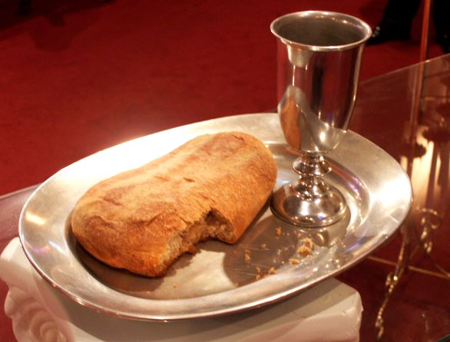

**Informal mid-week Communion**

Thursdays at 10.30am in the Fellowship Room

*An Oasis of peace in a busy week*

**Cyncoed Church Premises**

**For Out of Hours or Emergency access to the Cyncoed Church Premises**

**please call Martin on 07849 632 394 or**

**email:**[**cyncoedmethodistchurch@gmail.com**](mailto:cyncoedmethodistchurch@gmail.com)

T

Please send items for the church notices to the Church Office

or email to cyncoedmethodistchurch@gmail.com

before 5.00pm on Wednesday.