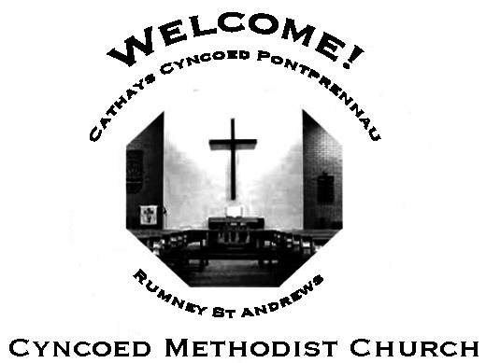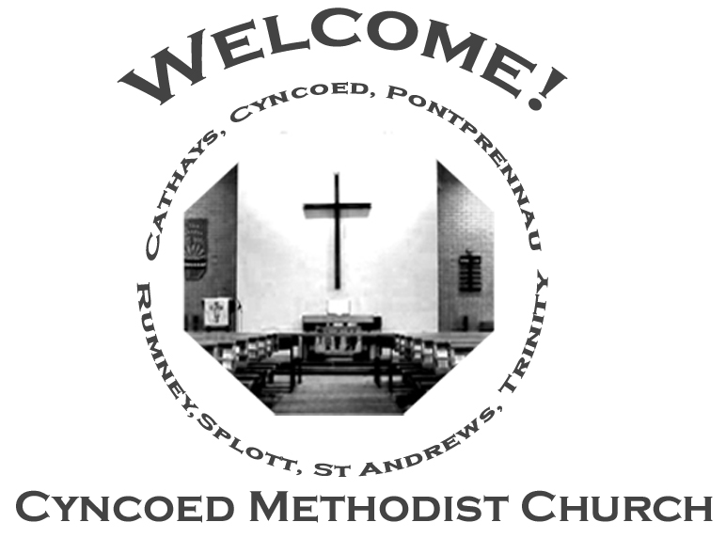+- aster da

***Services***

**Steward: Sue Tester**

**10.30am Maurice Wentworth**

**6.00pm Circuit - Thanksgiving Service**

**Readings*:*** *Acts 5: 27-32; Psalm 118: 14-29 or Psalm 150; Revelation 1: 4-8;*

*John 20: 19-31*

**Church Notices for Sunday 24th April 2022**

**Second Sunday of Easter**

***At Cyncoed Methodist Church***

We are called to tell God’s story by living as God’s people through:

* Preaching and teaching the gospel
* Encouraging spiritual growth
* Outreach in the community
* Responding to opportunities for change

**All inspired by God centred worship and prayer**.

**Ongoing Covid Precautions:**

**The World Health Organisation clearly recognises that we are still in the middle of the Covid-19 pandemic, with some localities facing increasingly rapid rates of infection. In order to protect all members of the congregation we ask that congregants and visitors: Continue to wear face coverings when inside the church buildings (unless medically exempt). Avoid sitting too close to people who they do not reside with**

Continue to wear face coverings when inside the church buildings (unless medically exempt)

Avoid sitting too close to people who they do not reside with

# Gentle in your love

Make me gentle in your love, Lord

Make me kind to every man;

Let me learn that I need others

To be all that I am.

Make me cry when I am stone, Lord;

Make we warm when I am cold;

Make me wise when I am young, Lord,

And young when I am old.

I am yours and you are mine, Lord,

And together we are one,

And, out of that, new life is born

And love again begun

***We continue to pray for those members of our Church Family and Friends who are unwell and all those who mourn.***

**Church Family News and Prayers**

**Notices**

* **Circuit Thanksgiving Service, Sunday 24th April, 6pm:**

This month the Service will be held at Cyncoed Methodist as well as on Zoom and will be celebrating and giving thanks for the Ministry of the Oborski Family and for Dave Kitchen’s 50 years as a Local Preacher.

All are welcome, either in person or on Zoom.

* **Desert Island Hymns:** a Songs of Praise Service, supporting Christian Aid will be at Christchurch, Llanedeyrn Drive on Sunday 15th May at 4pm.

**The Ministerial Team:**

**Rev. Kofi Amissah**

*Tel: 029 2030 8392* [*kofi.amissah@methodist.org.uk*](mailto:kofi.amissah@methodist.org.uk)

**Rev. Alexis Mahoney**

*Tel: 029 2030 0321* *revalexismahoney@gmail.com*

**Family & Community Lay Worker - Helen Osborne**

*Tel: 029 2039 3439, mobile 07788 701 129,* *helen.osborne11@btinternet.com*

**Church Office: 029 2039 3439**

*cyncoedmethodistchurch@gmail.com*

**Sunday 1st May 2022**

**Third Sunday of Easter**

**Steward: Alison Harrison**

**9.15am Rev. Kofi Amissah - Communion**

**Readings:** *Acts 9: 1-6 (7-20); Psalm 30; Revelation 5: 11-14; John 21: 1-19*

8

**Informal mid-week Communion**

Thursdays at 10.30am in the Fellowship Room

*An Oasis of peace in a busy week*

**Cyncoed Church Premises**

**For Out of Hours or Emergency access to the Cyncoed Church Premises**

**please call Martin on 07849 632 394 or**

**email:**[**cyncoedmethodistchurch@gmail.com**](mailto:cyncoedmethodistchurch@gmail.com)

T

Please send items for the church notices to the Church Office

or email to cyncoedmethodistchurch@gmail.com

before 5.00pm on Wednesday.