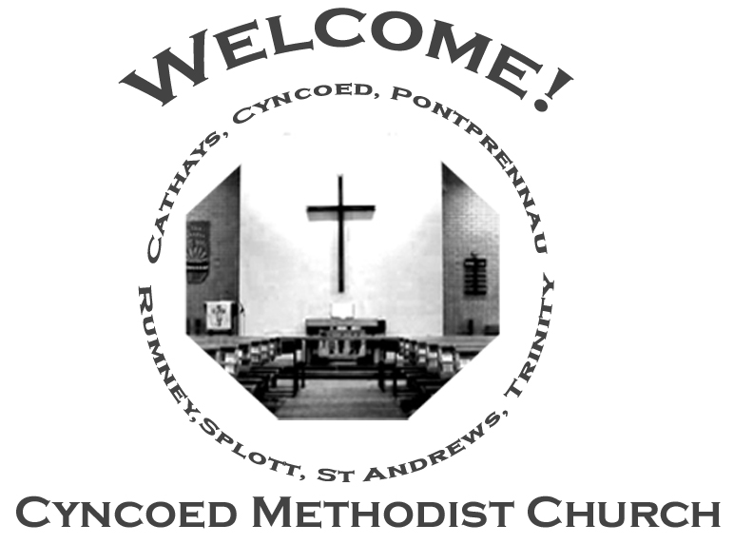+- aster da

***Services***

**Steward: Alison Harrison**

**9.15am Rev. Kofi Amissah - Communion**

**Readings:** *Acts 9: 1-6 (7-20); Psalm 30; Revelation 5: 11-14; John 21: 1-19*

**Church Notices for Sunday 1st May 2022**

**Third Sunday of Easter**

***At Cyncoed Methodist Church***

We are called to tell God’s story by living as God’s people through:

* Preaching and teaching the gospel
* Encouraging spiritual growth
* Outreach in the community
* Responding to opportunities for change

**All inspired by God centred worship and prayer**.

**Ongoing Covid Precautions:**

**The World Health Organisation clearly recognises that we are still in the middle of the Covid-19 pandemic, with some localities facing increasingly rapid rates of infection. In order to protect all members of the congregation we ask that congregants and visitors: Continue to wear face coverings when inside the church buildings (unless medically exempt). Avoid sitting too close to people who they do not reside with**

Continue to wear face coverings when inside the church buildings (unless medically exempt)

Avoid sitting too close to people who they do not reside with

Bible-Dipping

Our lives are a journey where we’re always looking for somewhere to call home. Back in Moses day, that was the Promised Land. Today we’re not travelling to somewhere across the river, we’re heading for heaven itself. But we need the spirit of Jesus lighting up our darkness and breathing through everything we do. *(Hebrews)*

Sit there doing nothing and you’ll get nothing. *(Proverbs 10)*

Focus on what God wants – you’ll be ambushed by total satisfaction; show mercy and he will be merciful to you; think the right things and God’s joy will break through the clouds in your life. *(Matthew)*

She says: ‘I’ve done my good deed for the day. Why not join me for a bad one, lovely boy!’ Are you tempted? Of course, you are. That’s why you need to think where on earth you’re going. *(Proverbs 7)*

It’s Jesus who makes it possible to enter right into the heart of God’s house. He gave up his life so that we might have a clean heart and find a door open for us. We can live for the first time as we were meant to live. *(Hebrews)*

Think about the roads you’re taking. Make wise choices and you will find something to treasure. *(Proverbs 8)*

***We continue to pray for those members of our Church Family and Friends who are unwell and all those who mourn.***

**Church Family News and Prayers**

**Notices**

* **Desert Island Hymns:** a Songs of Praise Service, supporting Christian Aid will be at Christchurch, Llanedeyrn Drive on Sunday 15th May at 4pm.
* **Summer Outreach**: If you would like to contribute an article for our next edition of OUTREACH please will you either email it to me or if written leave in the Office for my attention.  
  Deadline for submission is Sunday 22nd May  
  Look forward to hearing from you!!  
  Anne

**The Ministerial Team:**

**Rev. Kofi Amissah**

*Tel: 029 2030 8392* [*kofi.amissah@methodist.org.uk*](mailto:kofi.amissah@methodist.org.uk)

**Rev. Alexis Mahoney**

*Tel: 029 2030 0321* *revalexismahoney@gmail.com*

**Family & Community Lay Worker - Helen Osborne**

*Tel: 029 2039 3439, mobile 07788 701 129,* *helen.osborne11@btinternet.com*

**Church Office: 029 2039 3439**

*cyncoedmethodistchurch@gmail.com*

**Sunday 8th May 2022**

**Fourth Sunday of Easter**

**Steward: Jenny Siddall**

**10.30am Rev. Kofi Amissah - Communion**

**Readings:** *Acts 9: 36-43; Psalm 23; Revelation 7: 9-17; John 10: 22-30*

8

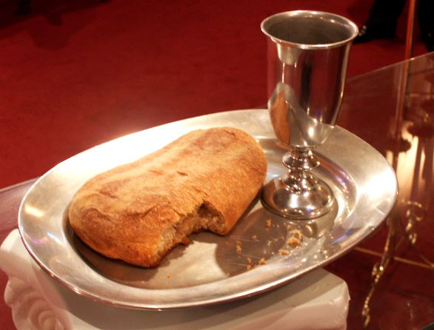

**Informal mid-week Communion**

Thursdays at 10.30am in the Fellowship Room

*An Oasis of peace in a busy week*

**Cyncoed Church Premises**

**For Out of Hours or Emergency access to the Cyncoed Church Premises**

**please call Martin on 07849 632 394 or**

**email:**[**cyncoedmethodistchurch@gmail.com**](mailto:cyncoedmethodistchurch@gmail.com)

T

Please send items for the church notices to the Church Office

or email to cyncoedmethodistchurch@gmail.com

before 5.00pm on Wednesday.